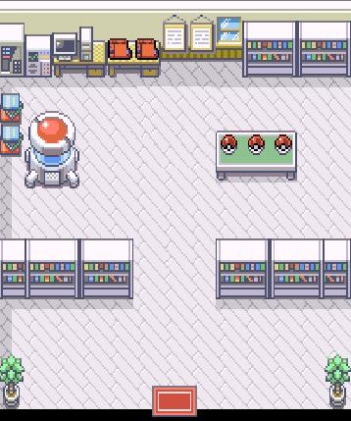**User Guide: Pokémon Amethyst**

The revolutionary video game, “Pokemon Amethyst” developed by TechNex and their lead directors Sadman Sazid, Japhet Elias and Imran Ali, has rocked the world with their brilliant video game. Pokémon Amethyst is a complex game with many layers this guide will help you make the most out of your experience.

**Getting Started**

When you start off your adventure in Maple Town, Ash has just woken up and has no Pokémon. You have to make your way outside and go to Professor Oak’s Lab. You have the option to interact with most of the objects in your home.

Once you have made it inside, you walk up to the 3 pokeballs and press x. You will then receive a Pikachu as your first Pokémon! You may now leave Oak’s Lab. If that’s hard to figure out, there is a note on the north wall that you can read. Remember you won’t interact with any Pokémon unless you pick up Pikachu.

**Training your Pokémon**

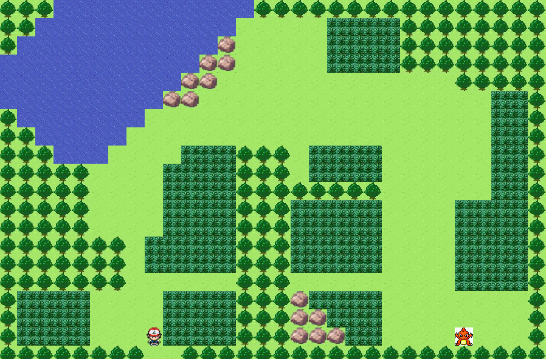As you go about Maple Town, you will need to enter the forest in order to train. You must walk into the high, dark grass area in order to encounter Pokémon to battle. When in battle, you choose which attack you what to use on the opposing Pokémon by using the directional arrows and pressing ‘x’.

You may encounter a problem where your Pokémon has fainted and needs to be revived at a local pokecenter. Go to the building below and talk to the clerk. She will revive your pokemon for you.

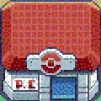

**The Final Battle**

Once your pokemon has reached the levels of 10 and beyond, you will be ready to fight charmander, the boss in the forest. He is located right at the bottom right of the forest. Even after you defeat charmander, you may still play the game as it is an open world game.

**Bugs**

There are some bugs in the game that you should be aware of. Due to functions not being optimized for efficiency and speed the user will notice that when entering Winterfell Forest that the time it takes to load the map is a bit long. This can be attributed to cheap but efficient secondary buffering methods. While waiting for the map to load if the user moves their player they will notice another bug where the previous map and the Winterfell Forest only partially load. Another bug is that if the user approaches the boss Charzar without a pokeball the player will be able to go right through the character and a block painting bug will be displayed. This also happens in some of the houses/labs in the game. A note should be made that all the bugs are only visual glitches and not game breaking bugs.